******UCAB**

UCAB is Cable Arm Positioning’s universal microcontroller/PLC. UCAB is offered as a bare board, or as a complete product. UCAB is perfect for custom applications. Upgrades to include GPS and solar charging are coming soon!

What Can It Do? Outputs

* CALC Depth System CANOpen
* Water Level Measurement RS-232 x1
* Data Hub Analog x1
* DQM Compliancy USB
* Custom applications I2C
* 900Mhz Data Telemetry built in
* Cellular Communications Inputs
* 4-40 VDC input 2x npn open collector
* Clean 12VDC output CANopen
* Onboard barometer RS-232
* Onboard temperature Analog
* Onboard voltage detector
* Onboard 6 axis accelerometer
* 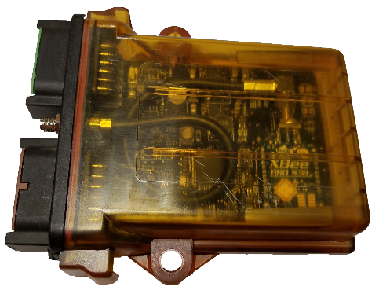Weather tight enclosure

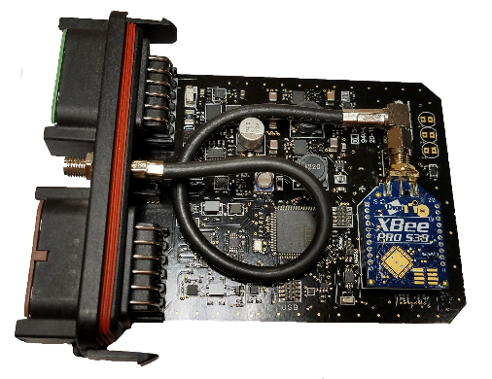

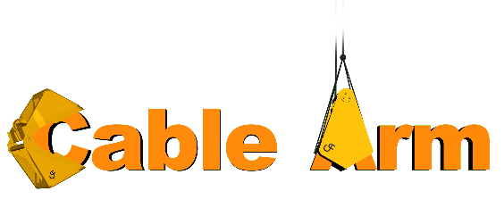

[Harry@cablearm.com](mailto:Harry@cablearm.com) ● [www.cablearm.com](http://www.cablearm.com) ● Phone 734.676.6108 x2